 

**WORKSHEET – 1.2**

**Name:**Rahul Maurya

**Section/Group:** 716 / “A”

**UID:** 20BCS7260

**Subject:** Software Engineering Lab

**Date of Submission:** 20.2.2022

**Branch:** BE CSE (4th Semester)

**Aim:**

Suppose your organization is planning to develop a travel application. Design a software requirement system for the given project.

1. **Introduction**

**Purpose:**

This software is for the automation of travel booking activities of a travel agency. We can store all the data regarding booking, tourist places and all the information regarding hotel, travel agency.

**CHANDIGARH UNIVERSITY SOFTWARE ENGINEERING LAB**

 

**Document Convention:**

|  |  |
| --- | --- |
| **Abbreviations** | **Full Forms** |
| DB | Database |
| Info | Information |
| ER | Entity Relationships |
| DFD | Data Flow Diagram |
| SRS | Software Requirement Specification |

**Intended Audience:**

This project is for the travel agency. This has been implemented under the guidance of agency management. This project is useful for the everyone who loves to travel.

**Project Scope:**

The proposed software product is travel agency management system. This product will be used in any travel agency to get information and data from customers who booked by this application and storing the info in the database and using it for further use. The current system is a paper based system, which is too slow and cannot provide updated information about the booking.

**References:**

* [**www.google.com**](http://www.google.com)
* [**www.slideshare.net**](http://www.slideshare.net)
* [**www.wikepedia.com**](http://www.wikepedia.com)

**CHANDIGARH UNIVERSITY SOFTWARE ENGINEERING LAB**

 

1. **Overall Description**

**Product Perspective:**

* **USER:** The user can make all the customer entries and the total booking, and the pay the amount.
* **ADMIN:** The admin can see all the information about the customers, booking information, agency and the admin can add the details too.
* **MANAGEMENT:** The management can add all the information regarding agency like cost, places, booking, update the information of customer etc.

**CHANDIGARH UNIVERSITY SOFTWARE ENGINEERING LAB**

 

**Product Features:**

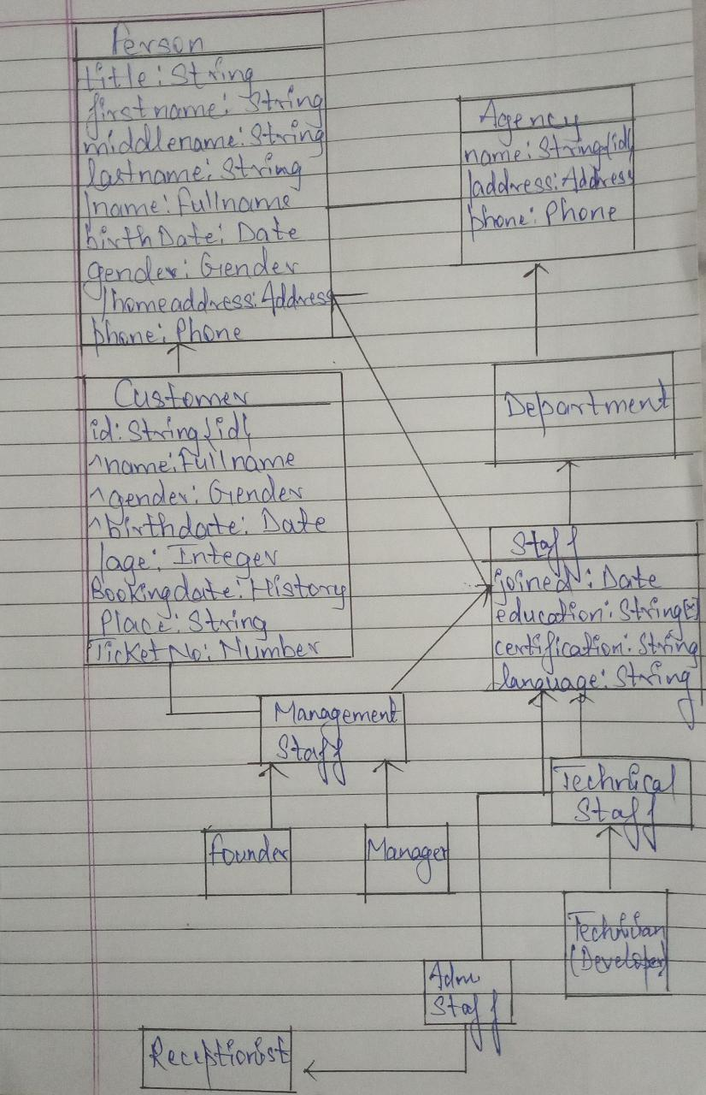

**CHANDIGARH UNIVERSITY SOFTWARE ENGINEERING LAB**

 

**Operating Environment**

Operating environment for the travel application is as listed below:

* Database
* Client / Server system
* Operating System: Windows
* Database: SQL Database(XAMMP)
* Platform: HTML / Java

**Design and Implementation Constraints:**

* SQL commands for above queries / applications.
* Implement the database at least using a centralize database management system.

**Assumption Dependencies:**

Let us assume that this is a distributed travel application and it is used in the following application:

* A request for the application and customers information.
* Calculation of customers and calculating appropriate booking of the customers.

**CHANDIGARH UNIVERSITY SOFTWARE ENGINEERING LAB**

 

1. **System Features:**

**Description and Priority**

The travel application maintains information on customers, bookings and and about the agency. Of course, this project has a high priority because it is very difficult to visit any agency without prior information.

**Stimulate / Response Sequences**

* To do booking.
* Display a detailed list of places, available seats.
* Confirmation of booking, payment.

**Functional Requirements**

* **Distributed Database:**

Distributed database implies that a single application should be able to operate transparently on data that is spread across a variety of different databases and connected by a communication network.

* **Client / Server System:**

The term client/server refers primarily to an architecture or logical division of responsibilities, the client is the application (also known as the front-end), and the server is the DBMS (also known as the back-end).

**CHANDIGARH UNIVERSITY SOFTWARE ENGINEERING LAB**

 

A client/server system is a distributed system in which,

* Some sites are client sites and others are server sites.
* All the data resides at the server sites.
* All applications execute at the client sites.

1. **External Interfaces Requirement**

**User Interface**

* Front-end software: HTML and JSP
* Back-end software: Xampp Database.

**Hardware Interface**

* Windows.
* A browser which supports CGI, HTML & JavaScript.

**Software Interface**

Following are the software used for the university management system

|  |  |
| --- | --- |
| **Software Used** | **Description** |
| **Operating System** | We have chosen Windows operating system for its best support and user-friendliness. |
| **Database** | To save the customer records, booking, other records we have chosen MySQL database |

**CHANDIGARH UNIVERSITY SOFTWARE ENGINEERING LAB**

 

|  |  |
| --- | --- |
| **HTML** | To implement the project we have chosen HTML language for its more interactive support. |

**Communication Software**

This project supports all types of web browsers. We are using simple electronic forms for the booking, payment and for contact with agency.

1. **Non Functionality Requirement:**

**Safety Requirements**

If there is extensive damage to a wide portion of the database due to catastrophic failure, such as a disk crash, the recovery method restores a past copy of the database that was backed up to archival storage (typically tape) and reconstructs a more current state by reapplying or redoing the operations of committed transactions from the backed up log, up to the time of failure.

**Security Requirement**

Security systems need database storage just like many other applications. However, the special requirements of the security market mean that vendors must choose their database partner carefully.

**Soft Quality Attributes**

* **Availability:** The agency should be available on the specified time as many customers are waiting for their turn in the queues.

**CHANDIGARH UNIVERSITY SOFTWARE ENGINEERING LAB**

 

* **Correctness:** The customer should be treated at correct time and should be treated well according to their needs.
* **Maintainability:** The Admin and User in chargers should maintain correct data of customers, booking, agency etc.
* **Usability:** The agency schedules should satisfy a maximum number of customer needs.

**CHANDIGARH UNIVERSITY SOFTWARE ENGINEERING LAB**